|  |
| --- |
| Photo displaying partial image of two pie charts on a canvas-textured page |
| PO3_DGW_CDD |
|  |

# Status Table

|  |  |
| --- | --- |
| PO3_DGW_CDD | |
| *Version* | V0.0 |
| *Status* | Draft |
| *Author* | Ghada Mohammed |
| *Last updated date* | March 8, 2020 |

# Table of history

|  |  |  |  |
| --- | --- | --- | --- |
| *Version* | *Author* | *Date* | *Changes* |
| 0.0 | Ghada Mohammed | March 8, 2020 | Creation of CDD document |

# References

|  |  |  |  |
| --- | --- | --- | --- |
| Ref. Number | Doc. Name | Version | Status |
| 1 | PO3_DGW_GDD | 0.2 | Proposed |

Contents

Status Table 2

Table of history 2

References 3

1 - Project Description 5

1.1 Major Features 5

2 - Context Diagram 6

3 - Input/output Table 7

4 - Software Feature 8

5 - Layered Architecture 9

6 - API’s Component 10

# 1 - Project Description

This section introduces the Global Design Document (GDD) for the Digital Watch and the high level design including software contexts diagram which demonstrates the high level design of the system and which input go through and produce certain output, software features and Layard architecture of the component.

## 

## Major Features

The major feature of the digital watch as listed below.

* Display time with 12 AM/PM format.
* Adjust time.
* Alarm to set according to user input.
* Stopwatch (Start, Stop).
* Three buttons to control the system:
  + MODE
  + FUNC1
  + FUNC2

# 2 - Context Diagram

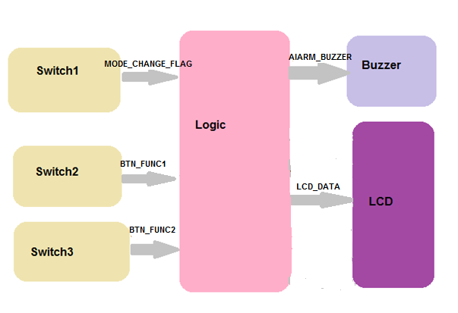

Figure 1.Software Context.

# 3 - Data Modularity “Global”

|  |  |  |  |
| --- | --- | --- | --- |
| Direction | Signal | Range | Unit |
| I/P | MODE_CHANGE_FLAG | 0:1 | NA |
| I/P | BTN_FUNC1 | 0:4 | NA |
| I/P | BTN_FUNC2 | 0:1 | NA |
| I/P | CURRENT_WATCH_STATE | 0:1 | Current Time |
| O/P | ALARM_BUZZER | 0:1 | On/off |
| O/P | CURRENT_MODE | 0:2 | NA |
| O/P | CURRENT_HOUR | 0:11 | Time-hours |
| O/P | CURRENT_MINUTE | 0:59 | Time-minutes |
| O/P | ADJUST_FIELD_SELECT | 0:1 | NA |
| O/P | CURRENT_FORMAT | 0:1 | NA |
| O/P | COUNTER_SECOND | 0:59 | Time-seconds |
| O/P | COUNTER_MINUTE | 0:59 | Time_Minutes |

# 6 - API’s Component

|  |  |
| --- | --- |
| Req.ID | Req_P03DGW_GDD_01_V01 |
| Covered ID | Req_P03DGW_SRS_001_V05 |
| Req_P03DGW_SRS_002_V05 |
| Req_P03DGW_SRS_003_V05 |
| Description | This API is responsible of changing and Navigate between mode of Digital watch, 1st press the Display time mode, 2nd  press the Alarm mode, 3rd press the Stopwatch mode and 4th press back to Display Time mode and so on. |
| Name | DGW_error_tModeNavigation |
| Input Argument | u8 Loc_u8Mode_Switch u8 *Loc_u8ReturnCurntMode |
| Return Type | error_t : OK/NOK |

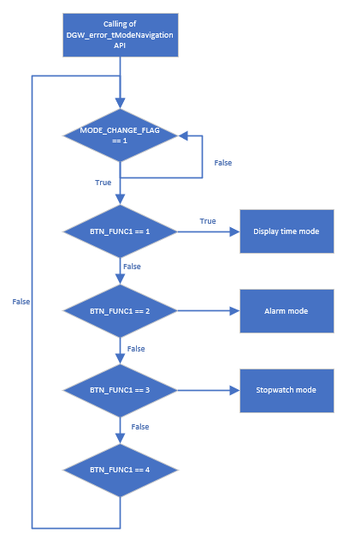

|  |  |
| --- | --- |
| Req.ID | Req_P03DGW_GDD_02_V01 |
| Covered ID | Req_P03DGW_SRS_004_V05 |
| Req_P03DGW_SRS_005_V04 |
| Req_P03DGW_SRS_013_V04 |
| Description | This API is responsible of enter the Display Time Mode which inside calling LCD component to display Initialization format of clock and calling Adjust clock component at the beginning of the function and after adjusting the time show the current time. |
| Name | DisTimMd_error_tInitialization |
| Input Argument | u8* Loc_u8Returnvalue |
| Return Type | error_t : OK/NOK |

|  |  |
| --- | --- |
| Req.ID | Req_P03DGW_GDD_03_V01 |
| Covered ID | Req_P03DGW_SRS_006_V05 |
| Req_P03DGW_SRS_007_V05 |
| Description | This API is responsible of read if the switch is pressed or not and assign the return value to pointer to integer. |
| Name | SW_error_tReadSwitchValue |
| Input Argument | u8 Loc_u8SwitchNo u8 *Loc_u8ReturnValue |
| Return Type | error_t : OK/NOK |

|  |  |
| --- | --- |
| Req. ID | Req_PO3DGW_GDD_04_V01 |
| Covered ID | Req_P03DGW_SRS_006_V05 |
| Req_P03DGW_SRS_012_V05 |
| Req_P03DGW_SRS_014_V05 |
| Req_P03DGW_SRS_021_V05 |
| Description | This API is responsible of select between field of the digital watch to be ready adjusted and if reached to format mode and Func1_sw is pressed the Digital watch save the last modification and exit the adjusting. |
| Name | LCD_error_tFieldSelect |
| Input Argument | u8 Loc_u8Func1Switch |
| Return Type | error_t : OK/NOK |

|  |  |
| --- | --- |
| Req.ID | Req_PO3DGW_GDD_5_V01 |
| Covered ID | Req_P03DGW_SRS_007_V05 |
| Req_P03DGW_SRS_008_V05 |
| Req_P03DGW_SRS_009_V05 |
| Req_P03DGW_SRS_010_V05 |
| Req_P03DGW_SRS_011_V05 |
| Req_P03DGW_SRS_015_V05 |
| Req_P03DGW_SRS_016_V05 |
| Req_P03DGW_SRS_017_V05 |
| Req_P03DGW_SRS_018_V05 |
| Req_P03DGW_SRS_019_V05 |
| Req_P03DGW_SRS_020_V05 |
| Description | This API is responsible of increment the value of which field is selected if a hours is selected doesn’t exceed more than 11 then reset to 0 and if minutes is selected doesn’t exceed more than 59 then reset to 0 and if format is selected toggle between AM and PM |
| Name | LCD _error_AdjustTime |
| Input Argument | u8 Loc_u8Func2Switch |
| Return Type | error_t : OK/NOK |

|  |  |
| --- | --- |
| Req.ID | Req_PO3DGW_GDD_6_V01 |
| Covered ID | Req_P03DGW_SRS_013_V04 |
| Description | This API is responsible of enter the Alarm Mode which inside calling LCD component to display Initialization format of clock and calling Adjust Alarm component. |
| Name | AlarmMode_error_tInitialization |
| Input Argument | u8* Loc_u8Returnvalue |
| Return Type | error_t : OK/NOK |

|  |  |
| --- | --- |
| Req.ID | Req_PO3DGW_GDD_7_V01 |
| Covered ID | Req_P03DGW_SRS_022_V05 |
| Req_P03DGW_SRS_007_V05 |
| Description | This API is responsible of compare between the current time and the value of alarm set (H=H && M=M && format==format ) |
| Name | Alarm_error_tAlarmCheck |
| Input Argument | u8 *Loc_u8ReturnValue |
| Return Type | error_t : OK/NOK |

|  |  |
| --- | --- |
| Req.ID | Req_PO3DGW_GDD_8_V01 |
| Covered ID | Req_P03DGW_SRS_023_V05 |
| Req_P03DGW_SRS_024_V04 |
| Description | This API is responsible of Enable Buzzer to ring |
| Name | Buzzer_error_tFireAlarm |
| Input Argument | Loc_u8State (Enable/Disable) u8 Loc_u8buzzerNo u8* Loc_u8RetrunValue |
| Return Type | error_t : OK/NOK |

|  |  |
| --- | --- |
| Req.ID | Req_PO3DGW_GDD_9_V01 |
| Covered ID | Req_P03DGW_SRS_025_V04 |
| Description | This API is responsible of enter the Stop watch which inside calling LCD component to display Initialization format of cloc and after reset the time show the current time. |
| Name | StopWatch_error_tInitialization |
| Input Argument | u8* Loc_u8Returnvalue |
| Return Type | error_t : OK/NOK |

|  |  |
| --- | --- |
| Req.ID | Req_PO3DGW_GDD_5_V01 |
| Covered ID | Req_P03DGW_SRS_026_V05 |
| Req_P03DGW_SRS_027_V01 |
| Req_P03DGW_SRS_028_V01 |
| Req_P03DGW_SRS_029_V01 |
| Req_P03DGW_SRS_030_V01 |
| Req_P03DGW_SRS_031_V01 |
| Req_P03DGW_SRS_032_V01 |
| Description | This API is responsible of starting the counting up of stop watch and reset after if user desire. |
| Name | StopWatch_error_tCountingUp |
| Input Argument | u8 Loc_u8Func1Switch(start) u8 Loc_u8Func2Switch(reset)  u8* Loc_u8Returnvalue |
| Return Type | error_t : OK/NOK |